# **1 Introduction**

* 1. **Purpose of the system**
  2. **Scope of the System**
  3. **Core system functionalities**
  4. **Objectives and success criteria of the project**
  5. **Definitions, Acronyms, and Abbreviations**
  6. **References**

1. **Current System**
2. **Proposed System**
   1. **Overview**

The proposed system will be web based. The application will allow the user to locate salons in the given location, find out which hairstyles those salons offer and the price ranges.

* 1. **Functional Requirements**

|  |  |  |
| --- | --- | --- |
| **Identifier** | **Priority\*** | **System requirement** |
| REQ1 | 5 | The system shall allow the user to create an account and sign in via Facebook, Gmail account or manually. |
| REQ2 | 5 | If the user isn’t logged in, the system shall allow the user to be able to search for salons by hair category. |
| REQ3 | 5 | The system shall display the pictures of the hairstyles of hair category the user searched for. |
| REQ4 | 5 | If the user is not a registered user, then upon clicking a picture, the system should allow the user to register via either Facebook, Gmail or manually. |
| REQ5 | 5 | If the user is a registered user, the system should allow the user to search salons by location and hair category. |
| REQ6 | 5 | The system should allow a registered user to book an appointment at the salon of their choice for the hair category they searched for. |
| REQ7 | 2 | The system should allow the user to like and share a hairstyle on Facebook. |
| REQ8 | 3 | The system should allow salons to update information about their businesses. For example, Salon name, Category, Tags, Address, Contact Information, Website, Rating, Trading hours. |
| REQ9 | 5 | The system should allow the user to view salon location on a map. |
| REQ10 | 5 | The system should allow the user to see how far the salon is from their current location on a map and plot the nearest route to the particular map. |
| REQ11 | 3 | The system should allow the user to change password and registered email. |
| REQ12 | 4 | The system should allow the user to be able to de-activate account. |
|  |  |  |

# *Rating goes from 1 being of lowest priority to 5 being of the highest priority.

* 1. **Non-Functional Requirements**
     1. **Usability**
     2. **Reliability**

### Components of the project code will be tested alongside the implementation phase to ensure that they are functional.

* + 1. **Performance**

The system’s response time will vary, based on the web browser and the user’s network bandwidth. The optimum response time of the system is under two seconds. The web server being utilized for this system, Apache, can host a maximum of 256 concurrent connections, therefore the system will be able to accommodate 256 concurrent connections. The worst latency that the system will experience is 3.7 sec, based on the web server’s bandwidth.

* + 1. **Supportability**

The system will be made into a mobile application, allowing the find-the-shortest-route feature on the system to be more dynamic. The system will be maintained by a team of programmers and software engineer.

* + 1. **Implementation**
    2. **Availability**

Since the system is web based, there is no need for installation. The system will run on any web browser, therefore it is not limited to any operating system or platform.

* + 1. **Hardware**

The system will require any platform that has some sort of connection to the internet. Every function that this system utilizes depends on connecting to the database which the webserver hosts, from searching for hair salons by name to finding the shortest route to the salon.

* + 1. **Software**

For the system to be operational, one must have installed the most recent version of the web browser. Since this is a web-based application, the web browser must be able to accommodate JavaScript code, some functions, such as the log in window, are written in JavaScript.

* + 1. **Security**

Most of our security will be focused of the login and registration of the user. All of the information the use inputs will be encrypted before being sent to our server.

Once the user is registered, the system will allow the user three attempts at logging in. Failing to give a correct password in these three attempts will result in the system asking the user to reset the password by sending a link to the email they entered when registering.

* + 1. **Interface**

Since the system is web based, the system will interact with the user’s web browser and the web server hosting the system. The data between the user’s inputs and the system’s results will be transferred via the network the user is connected to. The system will be able to run on the any version of web browser.

* + 1. **Assumptions / Constrains**

To make use of any of the functions the system offers, the system must have registered the potential user. If the system can’t identify the user then the system must prompt the potential user to register.

* 1. **System Models**
     1. **Stakeholders**

**Client:** They would like to use the system to know where they can find the nearest salons and the salons of their choice.

* + 1. **Actors and Goals**

|  |  |  |
| --- | --- | --- |
| **ACTOR** | **ACTOR’S GOALS** | **USE CASE NAME** |
| Client | To create an Account. | UC-1 SignUp |
| Client | To Sign In to the system. | UC-2 SignIn |
| Client | To change password. | UC-3 ChangePassword |
| Client | To be able to de-activate the Account. | UC-4 De-Activate |
| Client | To search for salons by location. | UC-5 SearchByLocation |
| Client | To search for salons by hair category | UC-6 SearchByHairT |
| Client | To be able to see where the salon is situated on Google maps and how far is it from the client’s location. | UC-7 ViewSalonOnMap |
| Client | To be able to get route from where the client is to the salon on Google maps. | UC-8 GetSalonRoute |
| Client | To be able to get salon address on Google maps salon position. | UC-9 GetSalonAddress |
| Client | To book an appointment with the salon. | UC-10 Book |
| Salon | To update their business information. | UC-11 InfoUpdate |
| Client | To be able to view hairstyle pictures. | UC-12 Photographs |
| Client | To be able to like and share a hairstyle on Facebook | UC-13 LikenShare |

* + 1. **Use Cases**
       1. **Casual Description**

**UC-1 Sign Up**

The client want to sign up and create an account so that she can have access to some other functionalities of the system.

**UC-2 Sign In**

The client signs in to the system.

**UC-3 Change Password**

The clients can change their password.

**UC-4 De-Activate**

The client can de-activate their accounts.

**UC-5 Search By Location**

The client can search for salons by their location.

**UC-6 Search By Treatment**

The client can search for salons by the treatment they offer.

**UC-7 View Salon On Map**

The client can view salon on the Google Map and get the distance from the clients location to the salon.

**UC-8 Get Salon Route**

The client can get the route from its current location to the salon on Google maps.

**UC-9 Get Salon Address**

The client willbe able to get salon address on Google maps salon position.

**UC-10 Book**

The client can be able to book an appointment with the salon.

**UC-11 InfoUpdate**

The salon can update their business information.

**UC-12 Photographs**

The client can view the hairstyle pictures.

**UC-13 LikenShare**

The client can like and share a post on Facebook.

* + - 1. **Use Case Diagram**

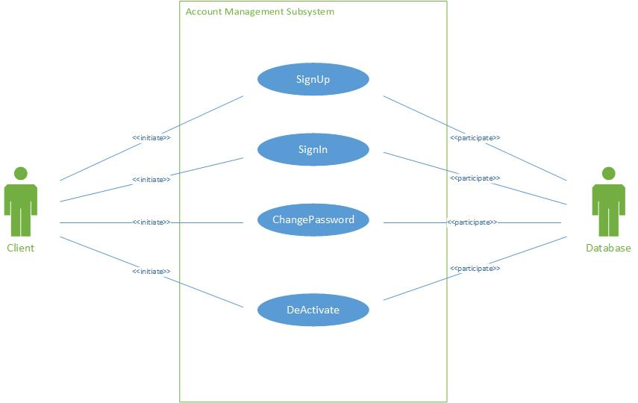

Figure 1 Use Case Diagram for Account Management Subsystem

**3.4.3.3 Traceability Matrix**

|  |  |  |  |  |  |  |  |  |  |  |  |  |  |  |
| --- | --- | --- | --- | --- | --- | --- | --- | --- | --- | --- | --- | --- | --- | --- |
|  | **Prior**  **ity**  **Weig-ht** | **UC1** | **UC2** | **UC3** | **UC4** | **UC5** | **UC6** | **UC7** | **UC8** | **UC9** | **UC10** | **UC11** | **UC12** | **UC13** |
| **REQ1** | 5 | X | X |  |  |  |  |  |  |  |  |  |  |  |
| **REQ2** | 5 |  |  |  |  |  | X |  |  |  |  |  |  |  |
| **REQ3** | 5 |  |  |  |  |  |  |  |  |  |  |  | X |  |
| **REQ4** | 5 | X |  |  |  |  |  |  |  |  |  |  |  |  |
| **REQ5** | 5 |  |  |  |  | X | X |  |  |  |  |  |  |  |
| **REQ6** | 5 |  |  |  |  |  |  |  |  |  | X |  |  |  |
| **REQ7** | 2 |  |  |  |  |  |  |  |  |  |  |  |  | X |
| **REQ8** | 3 |  |  |  |  |  |  |  |  |  |  | X |  |  |
| **REQ9** | 5 |  |  |  |  |  |  | X | X | X |  |  |  |  |
| **REQ**  **10** | 5 |  |  |  |  |  |  | X |  |  |  |  |  |  |
| **REQ**  **11** | 3 |  |  | X |  |  |  |  |  |  |  |  |  |  |
| **REQ**  **12** | 4 |  |  |  | X |  |  |  |  |  |  |  |  |  |
| **TOTAL WEIGHT** |  | 10 | 5 | 3 | 4 | 5 | 5 | 10 | 5 | 5 | 5 | 3 | 5 | 2 |

**3.4.3.4 Fully Dressed Descriptions**

|  |  |
| --- | --- |
| **Use Case UC1** | **Sign Up** |
| Related Requirements: | Req1 |
| Initiating Actor: | Client |
| Actor’s Goal: | To create an account |
| Participating Actors: | Database |
| Preconditions: | None worth mentioning |
| Post conditions: | A new client is added into the database. |
| Flow of Events for Main Success Scenario:  1. Client goes to home page, clicks on the hyperlink “Sign Up”.  2. System prompts the client to enter their details.  3. The client enters required details and then submits.  4. The System records the new data into the database and signals completion. | |

Table 3.4.3.3.1

|  |  |
| --- | --- |
| **Use Case UC2** | **Sign In** |
| Related Requirements: | Req1 |
| Initiating Actor: | Client |
| Actor’s Goal: | To sign in to the system |
| Participating Actors: | Database |
| Preconditions: | None worth mentioning |
| Post conditions: | A Client is signed in to the system. |
| Flow of Events for Main Success Scenario:  1. Client goes to home page, clicks on the hyperlink “Sign in”.  2. System prompts the client to enter their details.  3. The client enters required details and then submits.  4. System prepares a database query to verify whether the details provided are valid. | |

Table 3.4.3.3.2

|  |  |
| --- | --- |
| **Use Case UC3** | **ChangePassword** |
| Related Requirements: | Req11 |
| Initiating Actor: | Client |
| Actor’s Goal: | To change password |
| Participating Actors: | Database |
| Preconditions: | None worth mentioning |
| Postconditions: | System successfully updates the client’s password. |
| Flow of Events for Main Success Scenario:  1. The client clicks on sign in hyperlink.  2. The system displays the sign in form.  3. The client clicks on “Forgot Password” hyperlink.  4. System prepares a database query to verify whether the email address provided is in the database. If the email address is found in the database, then an email will be sent to the client with a link that when clicked will direct the client to a page where they can register a new password.  5. System prepares another database query to update the password.  6. Client will then login using the email address and the updated password. | |

Table 3.4.3.3.3

|  |  |
| --- | --- |
| **Use Case UC4** | **DEACTIVATE** |
| Related Requirements: | Req12 |
| Initiating Actor: | Client |
| Actor’s Goal: | To be able to de-activate the account. |
| Participating Actors: | Database |
| Preconditions: | None worth mentioning |
| Post conditions: | A client’s account is de-activated. |
| Flow of Events for Main Success Scenario:  1. Client clicks the deactivate account option.  2. The System records the new data into the database signifying that the account has be deactivated. | |

|  |  |
| --- | --- |
| **Use Case UC5** | **SearchByLocation** |
| Related Requirements: | Req10 |
| Initiating Actor: | Any Client |
| Actor’s Goal: | To search for salons by Location |
| Participating Actors: | Google Maps |
| Preconditions: | • The sets of salons and their locations are stored in the system database.  • The system displays the menu of available functions at the home page of the system, “search by hairstyle”, “search by location”, “search by price range” and “search by name”. |
| Postconditions: | A page with all salons in the location searched will be generated |
| Flow of Events for Main Success Scenario:  1. Client goes to home page search drop down menu, chooses option “search by Location”.  2. System allows client to enter the location.  3. System prepares a database query to search the database and returns all the salons in the location searched.  4. Clients can then select the salons of their choice. | |

|  |  |
| --- | --- |
| **Use Case UC6** | **SearchByCategory** |
| Related Requirements: | Req2, Req5 |
| Initiating Actor: | Any Client |
| Actor’s Goal: | To search for salons by Treatment |
| Participating Actors: | Database |
| Preconditions: |  |
| Postconditions: |  |
| Flow of Events for Main Success Scenario:  1. System allows client to selects a hairstyle category and search thereby.  2. System prepares a database query to search the database and returns all the salons which offer the category searched for.  3. Clients can then select the salons of their choice with the category searched for. | |

|  |  |
| --- | --- |
| **Use Case UC7** | **ViewSalonOnMap** |
| Related Requirements: | Req9, Req10 |
| Initiating Actor: | Any client |
| Actor’s Goal: | To be able to see where salon is situated on Google maps. |
| Participating Actors: | Google Maps |
| Preconditions: | • The set of salons and IP addresses stored in the system database.  • The system displays available options at the salon page, one of which is view salon on map. |
| Postconditions: | Google map shows position of salon. |
| Flow of Events for Main Success Scenario:   1. Client goes to home page and searches for the hair category of their choice. 2. The system will then provide another search option where the user has to select a location of the salon convenient for them. 3. The user will then select the location. 4. The system will then prepares a database query to retrieve all the salons in the user’s desired location that offers the selected hair category. 5. Then the system will compile a list of all the retrieved salons with two clickable buttons for each salon; the view salon on map and the view salon gallery buttons. | |

|  |  |
| --- | --- |
| **Use Case UC8** | **GetSalonRoute** |
| Related Requirements: | Req9 |
| Initiating Actor: | Any client |
| Actor’s Goal: | To be able to get route from where the client is to the salon on Google maps. |
| Participating Actors: | Google Maps |
| Preconditions: | • The set of salons and IP addresses stored in the system database.  • The system displays available options at the salon page, one of which is get route. |
| Postconditions: | Google maps calculates route from current position to salon position and shows route on map. |
| Flow of Events for Main Success Scenario:  1. System allows client to enter distance, or price, or hairstyle.  2. System shows results of salons with specified information. | |

|  |  |
| --- | --- |
| **Use Case UC9** | **GetSalonAddress** |
| Related Requirements: | Req9 |
| Initiating Actor: | Client |
| Actor’s Goal: | To be able to get salon address on Google maps salon position. |
| Participating Actors: | Google Maps |
| Preconditions: | • The set of salons and IP addresses stored in the system database.  • The system displays available options at the salon page, one of which is view salon on map. |
| Postconditions: | Google map shows position of salon. |
| Flow of Events for Main Success Scenario:   1. Client goes to home page and searches for the hair category of their choice. 2. The system will then provide another search option where the user has to select a location of the salon convenient for them. 3. The user will then select the location. 4. The system will then prepares a database query to retrieve all the salons in the user’s desired location that offers the selected hair category. 5. Then the system will compile a list of all the retrieved salons with the salon’s location details. | |

|  |  |
| --- | --- |
| **Use Case UC10** | **Book** |
| Related Requirements: | Req6 |
| Initiating Actor: | Client |
| Actor’s Goal: | To book an appointment with a salon. |
| Participating Actors: | Database |
| Preconditions: | None worth mentioning |
| Post conditions: | A new client is added into the database. |
| Flow of Events for Main Success Scenario:  1. Client goes to booking page.  2. System prompts the client to fill in the booking form.  3. The client enters required details and then submits.  4. The System would then send an email to the salon with the booking details and send a copy to the user. | |

|  |  |
| --- | --- |
| **Use Case UC11** | **InfoUpdate** |
| Related Requirements: | Req8 |
| Initiating Actor: | Client |
| Actor’s Goal: | To be able to update the salon information |
| Participating Actors: | Database |
| Preconditions: | Old information that has been registered in to the system. |
| Post conditions: | A new client’s information is added into the database. |
| Flow of Events for Main Success Scenario:  1. Client goes to an information page to add new details.  2. System prompts the client to enter new details.  3. The client enters required details and then submits.  4. The System records the new data into the database and signals completion. | |

|  |  |
| --- | --- |
| **Use Case UC12** | **Photographs** |
| Related Requirements: | Req3 |
| Initiating Actor: | Any Client |
| Actor’s Goal: | To be able to view hairstyle photographs. |
| Participating Actors: | Database |
| Preconditions: |  |
| Postconditions: |  |
| Flow of Events for Main Success Scenario:  1. Client goes to gallery page.  2. System prepares a database query to search the database and returns all the hairstyle pictures.  4. Clients can then select the picture to view it. | |

|  |  |
| --- | --- |
| **Use Case UC13** | **LikenShare** |
| Related Requirements: | Req7 |
| Initiating Actor: | Any Client |
| Actor’s Goal: | To be able to like and share posts on Facebook |
| Participating Actors: | Database |
| Preconditions: |  |
| Postconditions: |  |
| Flow of Events for Main Success Scenario:  1. Client goes to any share and like button and click it.  2. System prompts a facebook menu to choose whether to share publicly or to the personal timeline. | |

**3.4.3.5 System Sequence Diagrams**

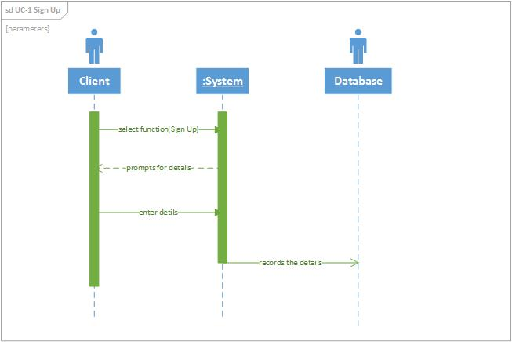

Figure 1 Sequence Diagram of Use Case 1

Figure 4-1 shows the sequence diagram of Use Case 1 which is “Sign Up”. It is used to create new client’s accounts. First the client clicks the “Sign Up” hyperlink. Next, the system prompts the client to enter their details. Then the client enters the required details. After that the system records the data into the database.

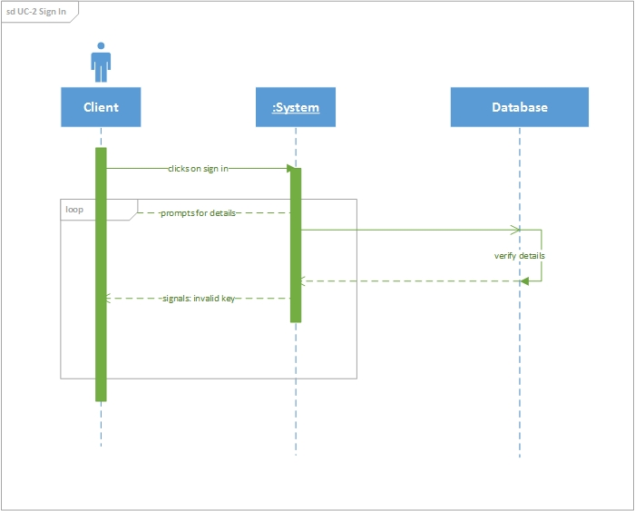

Figure 2 Sequence Diagram for Use Case 2

Figure 2 shows the sequence diagram of Use Case 2 which is “Sign In”. It is used to sign in clients. First the client clicks the “Sign In” hyperlink. Next, the system prompts the client to enter their details. Then the client enters the required details. After that the System prepares a database query to verify whether the details provided are valid.

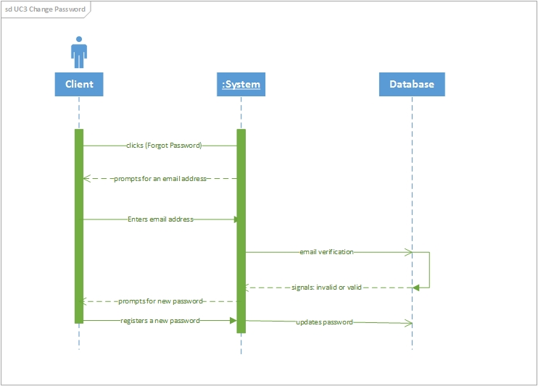

Figure 3 Sequence Diagram for Use Case 3

Figure 3 shows the sequence diagram of Use Case 3 which is “Sign In”. It is used to change a client’s password. First, the clients clicks the “Forgot Password” hyperlink and the system will prompt the client to enter a registered password. The system prepares a database query to verify whether the email address provided is in the database. If the email address is found in the database, then an email will be sent to the client with a link that when clicked will direct the client to a page where they can register a new password. Then after that the system will prepare another database query to update the old password.

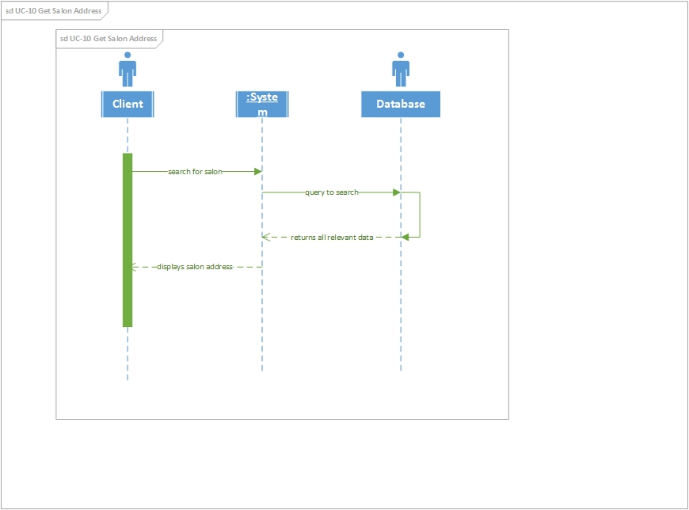

Figure 4 Sequence Diagram for Use Case 10

Figure 4 shows the sequence diagram of Use Case 10 which is “Get Salon Address”. It is used to get salon’s addresses. First, the clients searches for the salon either by hair-style, location or by price range. Then after that the system will allow the client to select the salon of their choice. Then the system will display the salon address.

Change Fig4.

* + 1. **Effort Estimation**

**Standard Equations:**

Duration = UCP + PF

UCP = UUCP*TCF*ECF

UUUCP = UAW + UUCW

**Definition**

Duration :- the length of time required to for the project.

UCP :- Use Case Point

PF :- Productivity Factor

UUCP :- Unadjusted UCP

The formula for calculating UCP is composed of three variables:

1. Unadjusted Use Case Points (UUCP), which measures the complexity of the functional requirements.

2. The Technical Complexity Factor (TCF), which measures the complexity of the nonfunctional requirements

3. The Environment Complexity Factor (ECF), which assesses the development team’s experience and their development environment.

UCP = UUCP × TCF × ECF

Unadjusted Use Case Points (UUCPs) are computed as a sum of these two components:

1. The Unadjusted Actor Weight (UAW), based on the combined complexity of all the actors in all the use cases.

2. The *Unadjusted Use Case Weight (UUCW)*, based on the total number of activities (or steps) contained in all the use case scenarios.

**4. Domain Analysis**

**4.1 Domain Models**

**4.1.1 Concept Definitions**

|  |  |  |
| --- | --- | --- |
| **Responsibility Description** | **Type** | **Concept Name** |
| Coordinate actions of all concepts associated with a use case, a logical grouping of use cases, or the entire system and delegate the work to other concepts. | D | Controller |
| Container for user’s authentication data, such as username, password, email address, etc. | K | Key |
| Verify whether or not the key-code entered by the user is valid. | D | KeyChecker |
| Prepare a database query to add new registered clients | D | Database connection |
| Verify and register a new password into the database | D | Password Changer |
| Deactivate the account | D | Deactivator |
| Drop down specifying the search parameters. | K | Search Requests |
|  |  |  |
| Prepare a database query that best matches the actor’s search  criteria and retrieve the records from the database | D | Database Queries |
|  |  |  |
|  |  |  |
|  |  |  |

**4.1.2 Association Definitions**

|  |  |  |
| --- | --- | --- |
| **Concept Pair** | **Association Description** | **Association Name** |
|  |  |  |
|  |  |  |

**4.1.3 Attribute Definitions**

|  |  |  |
| --- | --- | --- |
| **Concept** | **Attribute** | **Attribute Description** |

**4.1.4 Traceability Matrix**

**4.2 System Operation Contracts**

**Design of Tests**

**Test cases**

|  |  |  |
| --- | --- | --- |
| Test-case Identifier: | **TC-1** | |
| Use Case Tested: | **UC-6** | |
| Pass/fail Criteria: | **The test passes if the user enters a correct Facebook account or Google account with a correct password.** | |
| Input Data: |  | |
| Test Procedure: | | Expected Result: |
| **Step 1. Type in an incorrect email address and/or password** | | **System asks the user to ensure that the email address/password provided is correct; prompts the user to try again** |
| **Step 2. Type in the correct email address and password** | | **System redirects the user to another page;** |

|  |  |  |
| --- | --- | --- |
| Test-case Identifier: | **TC-2** | |
| Use Case Tested: | **UC-2 Sign In** | |
| Pass/fail Criteria: | **The test passes if the user enters a correct email address with a correct password.** | |
| Input Data: | Text | |
| Test Procedure: | | Expected Result: |
| **Step 1. Type in an incorrect email address and/or password** | | **System asks the user to ensure that the email address/password provided is correct; prompts the user to try again** |
| **Step 2. Type in the correct email address and password** | | **System redirects the user to another page;** |

|  |  |  |
| --- | --- | --- |
| Test-case Identifier: | **TC-3** | |
| Use Case Tested: | **UC-1 Sign Up** | |
| Pass/fail Criteria: | **The test passes if the user enters a valid email address with a password of not less than 6 characters.** | |
| Input Data: | Text | |
| Test Procedure: | | Expected Result: |
| **Step 1. Type in an invalid email address and/or password** | | **System asks the user to ensure that the email address/password provided is valid; prompts the user to try again** |
| **Step 2. Type in the correct/valid email address and password** | | **System registers the user to the database;** |

|  |  |  |
| --- | --- | --- |
| Test-case Identifier: | **TC-4** | |
| Use Case Tested: | **SearchByCategory** | |
| Pass/fail Criteria: | **The test passes when the user specifies the Hairstyle category in the list then the hairstyles corresponding to those categories ONLY appear on the Users screen.** | |
| Input Data: |  | |
| Test Procedure: | | Expected Result: |
| **Step 1. Select the Hairstyle Categories you want to view** | | **The selected categories will be marked** |
| **Step 2. Click on the Search Button** | | **The next page should be pictures of the Hairstyles that belong in the specified categories** |

|  |  |  |
| --- | --- | --- |
| Test-case Identifier: | **TC-5** | |
| Use Case Tested: | **UC-12 Photographs** | |
| Pass/fail Criteria: | **The test passes if the user can view all the pictures of hairstyles a salon has registered with our databases.** | |
| Input Data: |  | |
| Test Procedure: | | Expected Result: |
| **Step 1. Click on the View Gallery Button for any Salon** | | **The application redirects the user to a page with the picture gallery matched with that Salon.** |
|  | |  |